Opening code:

In R studio start by creating a new project by clickling the “new project button”  in the upper left of the screen.

To load my Git Hub repository click Version Control on the window that pops up.

Next click Git

Load my repository:

The link can be copied

My Github Link: <https://github.com/EmaleeO>

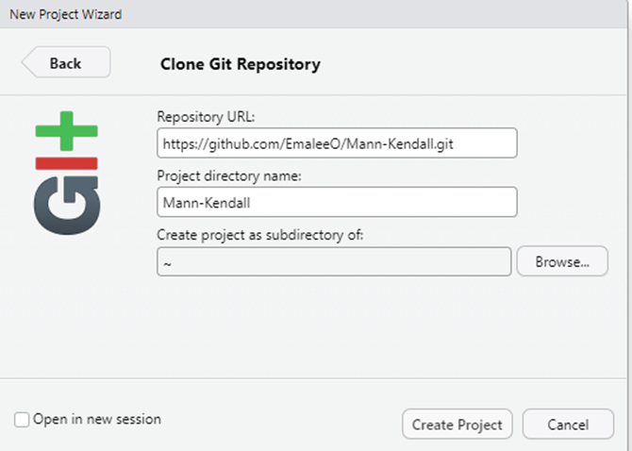

In this section the first time you open it, it will create a file on your computer. After that you need to click Browse and find the file it created

Now in the right hand corner click which file you want:

You will need to change

sharpe <- read_excel("/Users/eousley/OneDrive - beringstraits.com/Desktop/2024 Historical_Sharpe_Final FFA Report.xlsx")

Based on where you are opening your file from